IBSA Fund

Project Quarterly Report Template
Project Title: Resilient and Multifunctional Water Supply System for the Machubo Administrative Post-Marracuene District
Country: Mozambique | Reporting Period: January to March (Q1) 2026
Project start date (01/01/2025) | Project end date (31/12/2026)
Implementing Partner: UNDP Mozambique
Name & Email of Project Contact Person: Domingos Micas, domingos.micas@undp.org
Report Reviewed and Submitted by: Domingos Micas

1) Key achievements:
General Overview:
The project aims to improve climate-resilient access to safe water and sanitation in the Machubo Administrative Post, Marracuene District, through the construction of a solar-powered water supply system, rehabilitation of school sanitation facilities, and improvement of stormwater drainage channels. In addition, the project promotes institutional strengthening, community engagement, and gender-responsive approaches to ensure long-term sustainability of WASH services.

Key achievements during Q1 2026:
During the reporting period, the project made important progress in consolidating the technical foundation required for the implementation and construction phase, with a strong focus on site validation, technical assessment, and alignment of planned interventions with field realities.

Field visit for new proposed site validation: A field mission was conducted in March 2026. This joint technical mission confirmed that the initially selected site (Machubo Sede) for the water supply system is highly vulnerable to flooding, particularly following the recent heavy rains that caused significant inundations in Marracuene District and Machubo Sede in particular. This situation prompted the community to propose the relocation of the system to higher ground. As a result, three alternative locations (Matsonhe, Mabie, and Dzombo), all located in Macandza locality approximately 15 km from Machubo Sede, where affected families are being resettled, were identified and validated in coordination with local authorities and communities. This approach ensures a more resilient and sustainable solution for infrastructure development.

Technical assessments and data consolidation: Comprehensive field assessments were conducted for key infrastructure, including the secondary school and health center in Machubo Sede, as well as the drainage system. These assessments confirmed the degraded condition of existing facilities and provided critical data to inform the development of appropriate technical solutions.

Development of technical options: Based on field findings, preliminary technical options for the water supply system, sanitation facilities, and potential system configurations were developed. These options take into account factors such as population distribution, elevation, and service coverage, supporting evidence-based and context-responsive decision-making. At this stage, the project is awaiting formal approval of the new proposed site and associated activities to enable the consultant to proceed with detailed surveys and the finalization of the detailed engineering designs for the implementation and construction of the planned infrastructures.

Strengthened coordination and governance: The project maintained close coordination with key stakeholders, including DNAAS, district authorities, and UNDP teams. A Steering Committee (SC) meeting was successfully held on 03 March 2026, during which the 2026 Annual Work Plan (AWP) and the no-cost extension of the project were formally reviewed and approved by the SC, ensuring strategic alignment and continuity of implementation. Request for approval of project no cost-extension will be submitted to the IBSA Fund Manager during this week.

Progress towards implementation readiness: Key preparatory activities under the Annual Work Plan (AWP) progressed during the reporting period, including the consolidation of technical inputs required for design finalization and the preparation of subsequent procurement processes phase for construction works.

2) Direct and indirect beneficiaries of the project
2.1- Direct beneficiaries: See attached instructions on approach for direct and indirect beneficiaries.

Disaggregation | Cumulative Q1, 2026
Number of men | 0
Number of women | 0
At this stage (design and preparation phase), no direct beneficiaries have yet been reached.

2.2- Indirect beneficiaries: See attached instructions on approach for direct and indirect beneficiaries.
Disaggregation | Cumulative Q1, 2026
Number of men | 0
Number of women | 0
Indirect beneficiaries are not yet counted during this phase. However, the project is expected to benefit:
- 3,500 direct beneficiaries and 8,200 indirect beneficiaries upon implementation.

3. South-South cooperation
3.1- South-South cooperation indicators
Indicator | Actual achievement in reporting quarter | Comments if applicable
Number of examples of good practices in South-South cooperation transferred to developing countries with support by the IBSA Fund project | 0 | To be developed during implementation and construction phase
Number of South-South cooperation knowledge exchanges supported/facilitated by the IBSA Fund project. | 1 | Field mission involving multiple stakeholders, which provided a platform to discuss, assess, and align on alternative solutions for Machubo.
Number of evidence-based good practices documented based on the achievements of the IBSA Fund projects | 1 | Technical reports (Visit Report & Technical Options Report, submitted by the consultancy firm after the field mission held on march

3.2- Description of achievements related to South-South cooperation
During Q1 2026, the project facilitated multi-stakeholder technical engagement, including UNDP, government institutions, and consultants. The joint field mission served as a platform for knowledge exchange on climate-resilient water supply systems and site selection in flood-prone contexts.
The preparation of technical reports constitutes an initial step toward documenting context-specific good practices that can be shared across similar projects in developing countries.

4) Progress on Project Log-frame outcome and output indicators
Provide performance data on outcome and output level log-frame indictors of your Project. Provide self- assessed color coding [Red-Amber-Green (RAG)] on the suggested column in line with a RAG ‘Traffic Light’ rating. Performance data on outcome indicators to be reported once in a year during annual report.
GREEN | On track – 85%+ progress towards achievement of planned target for the year.
AMBER | At risk – 65-84% progress towards achievement of planned target for the year. Project team needs to identify particular measure(s) to overcome the low performance.
RED | Off track – progress below 65% towards achievement of planned target for the year. If two or more indicators are at risk, this scenario comes under serious concerns, and it should be escalated to the Management. This needs immediate attention with an action plan.

Result statements | Indicators | Baseline | Overall Project Target | Target for Reporting Year | Progress on Reporting Year | RAG Rating | Comments on variations
Outcome 1:  Improved access to safe and clean water services. | Number of people with access. | 0 | 3500 | 3500 | 0 | Amber | The implementation did not start. Project design under development
Output 1.1:  Construction of resilient and multifunctional water supply system. | System developed | 0 | 1 | 1 | 0 | Amber | Design phase ongoing
Outcome 2:  Improved water management for agriculture irrigation | Indicators | Baseline | Overall Project Target | Target for Reporting Year | Progress on Reporting Year | RAG Rating | Comments on variations
 | Drainage channels rehabilitated | 0 | 10 km | 10km | 0 | Red | Flood conditions in Machubo since January 2026 have significantly delayed the assessment of the drainage-related activities. As floodwaters remain in the area and timelines for improvement are uncertain, the feasibility of this component is currently under review, including the possibility of cancellation or reprioritization, pending further assessment and consultation with relevant stakeholders.
Output 2.1  Drainage channels works. | Km Rehabilitated | 0 | 10km | 10km | 0 | Red | The area remains largely inaccessible due to persistent flooding, with water levels still high and access routes severely affected, preventing proper technical assessments and delaying the implementation of planned activities.
Outcome 3:  Improved access to inclusive, climate-resilient sanitation and hygiene services in public institutions, | Indicators | Baseline | Overall Project Target | Target for Reporting Year | Progress on Reporting Year | RAG Rating | Comments on variations
 | Number of people with access | 0 | 3500 | 3500 | 0 | Amber | The project is currently under the design phase, with technical assessments completed and preliminary solutions identified. These preparatory activities are critical to ensure that the planned infrastructure responds to existing gaps, meets national standards, and incorporates gender-sensitive and climate-resilient features.
Output 3.1  Climate-resilient and gender-responsive sanitation and water supply facilities designed for the secondary school and health facility, in line with national standards and tailored to local needs. | Facilities improved in institutions | 0 | 2 (school &HCF) | 2 (school &HCF) | 0 | Amber | Design and assessment activities are underway, including the evaluation of existing infrastructure conditions and identification of appropriate technical solutions. The proposed interventions aim to address critical deficiencies, including lack of functional sanitation facilities, inadequate water supply, and poor hygiene conditions, particularly affecting women, girls, and vulnerable users. These efforts are laying the groundwork for the construction phase and ensuring that future infrastructure is sustainable, inclusive, and fit for purpose
Outcome 4:  Strengthened community capacity and ownership for climate-resilient infrastructure through effective engagement, training, and participatory monitoring | Indicators | Baseline | Overall Project Target | Target for Reporting Year | Progress on Reporting Year | RAG Rating | Comments on variations
 | 50 community members (disaggregated by gender) demonstrated improved knowledge on climate resilience, infrastructure use, and maintenance | 0 | 100% | 100% | 0% | Amber | Slight delay due to late rollout of training sessions and accessibility challenges during flooding periods
Output 4.1:  Community engagement, training, and monitoring systems established and operationalized to support sustainable infrastructure use and maintenance | 50 of community members trained on infrastructure management, DRR, and climate adaptation (disaggregated by gender and vulnerable groups) | 0 | 100% | 100% | 0% | Amber | Training sessions initiated later than planned due to procurement delays and weather disruptions
 | 100% of infrastructure sites with functional community-based monitoring mechanisms | 0 | 100% | 100% | 0% | Amber | Monitoring tools and reporting templates finalized late; capacity gaps still being addressed

5) Annual Work Plan (AWP) Activities implementation status – in over the reporting period*
SN | Activity | Status | Brief explanation on implementation status/achievements
1.1 | Community mobilization and awareness campaigns on climate risks and resilience measures | Partially completed | Initial community engagement sessions were conducted in targeted areas, reaching key local leaders and vulnerable groups. However, full rollout was delayed due to flooding constraints and accessibility challenges. Awareness materials were developed and are ready for broader dissemination in the next period
1.2 | Training of community members on infrastructure use, maintenance, and disaster risk reduction (DRR) | Partially completed | Training modules were developed and piloted, and several sessions delivered to community groups, with gender-balanced participation. Progress was slightly below target due to delays in procurement of service providers and logistical constraints caused by weather conditions.
2.1 | Procurement process for design and supervision consultancy services | Partially completed | The procurement process was launched; however, delays were experienced due to lack of responsive bids and the need to re-advertise and refine technical requirements. The process is ongoing and expected to be finalized in the next reporting period.
2.2 | Development of technical designs for resilient infrastructure (water, drainage, sanitation facilities) | Not implemented | This activity has not yet commenced due to delays in finalizing the procurement of consultancy services for design and supervision. Implementation is expected to start once the procurement process is completed.
3.1 | Preparation and launch of procurement packages for construction works | Not implemented | Preparation of procurement packages is pending completion of technical designs. As such, this activity has not started. Adjustments to the timeline may be required to align with revised implementation schedules.
3.2 | Construction of resilient infrastructure (schools, health facilities, drainage systems, water supply) | Not implemented | Construction activities have not yet started as they depend on completion of design and procurement processes. Delays in upstream activities have affected the overall implementation timeline.
3.3 | Establishment of community-based monitoring systems and committees | Partially completed | Initial steps were taken to identify and engage community representatives for monitoring committees. Draft monitoring tools and reporting templates were developed. Full operationalization is pending completion of training and formalization of committee structures.

6) Risk and Challenges
SN | Risk/Challenges | Internal/External | Mitigation measures taken or planned
1.1 | Initial project site highly prone to flooding | External | Relocation of the water supply system to higher, safer areas validated with stakeholders.
2.1 | Persistent high water levels affecting drainage assessment | External | Postponement of assessments until conditions improve; ongoing review of feasibility and potential reprioritization.
3.1 | Limited accessibility due to poor road conditions | External | Integration of access constraints into procurement and implementation planning (e.g., packaging of contracts, scheduling).
4.1 | Potential misalignment of scope (hospital, drainage components | Internal | Continuous alignment with AWP, DNAAS, and key stakeholders to ensure scope clarity and compliance

Annexes:
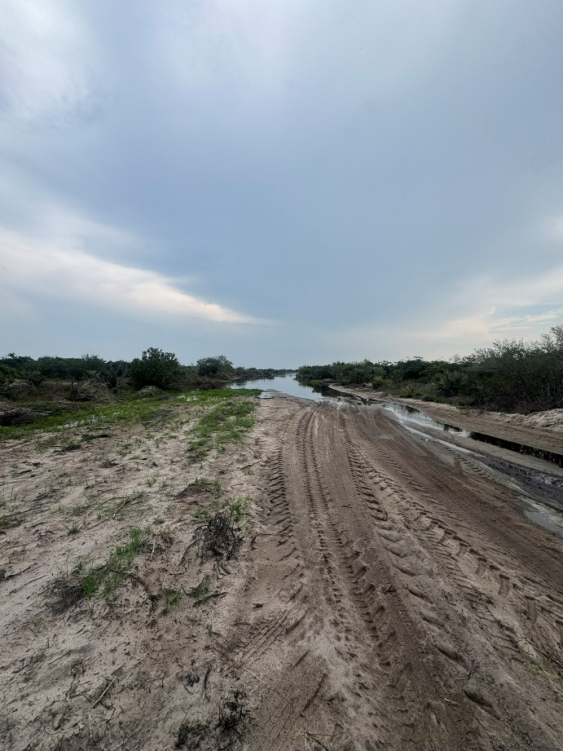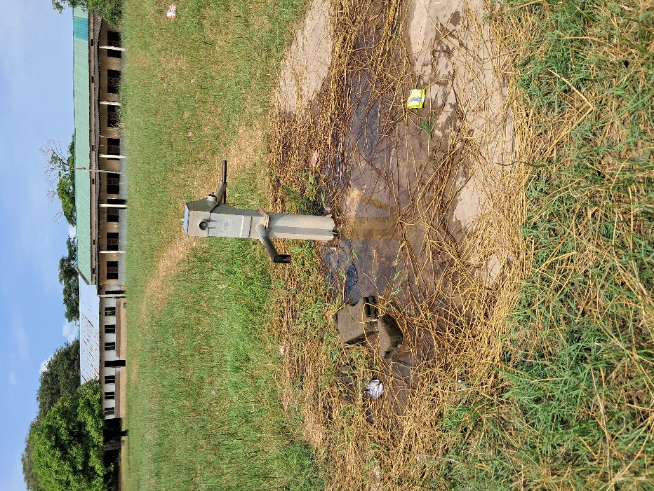
Picture: Handpump at Machubo Secondary School
Picture: Road from Macaneta to Machubo

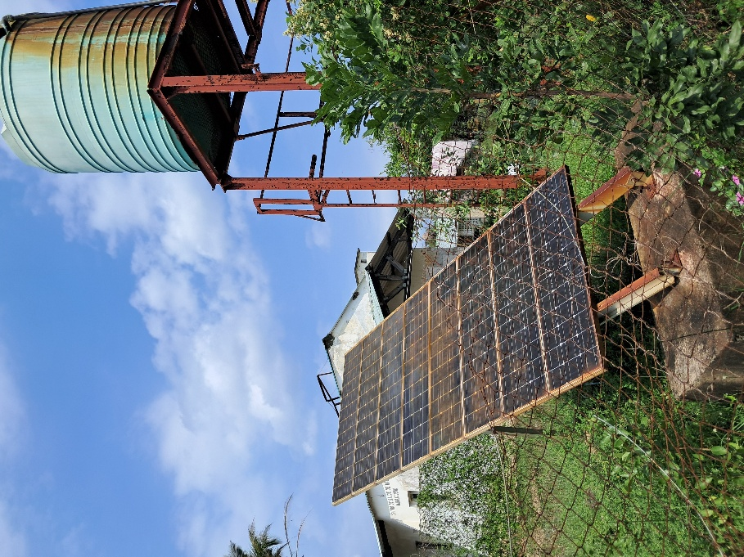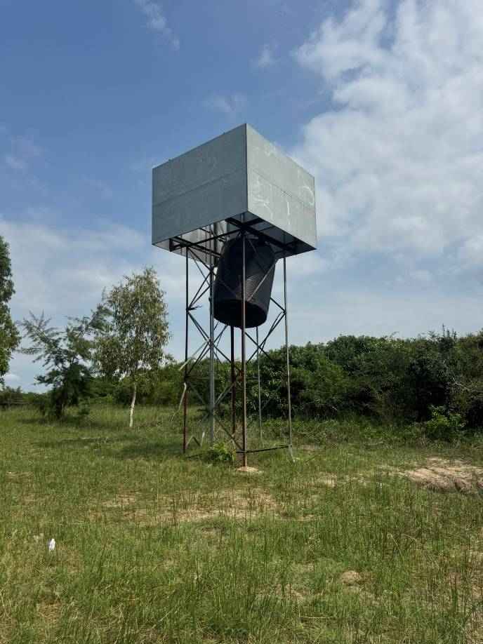
Picture: WSS at Machubo Secondary School (Broke)
Picture: WSS at Machubo Health Care Facilities
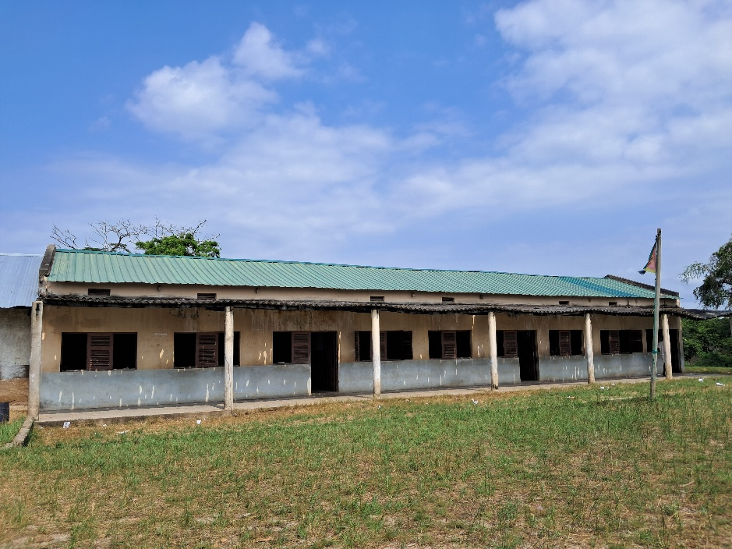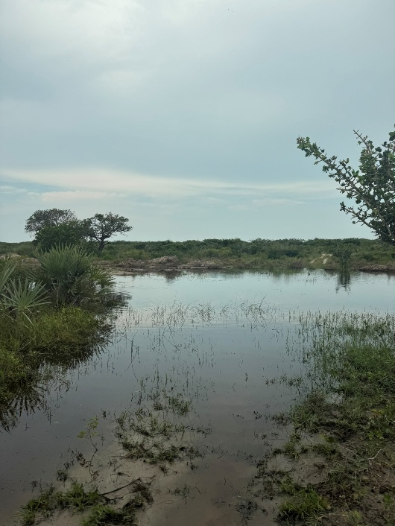
Picture: Road from Macaneta to Machubo
Picture: Machubo Secondary School Class Rooms

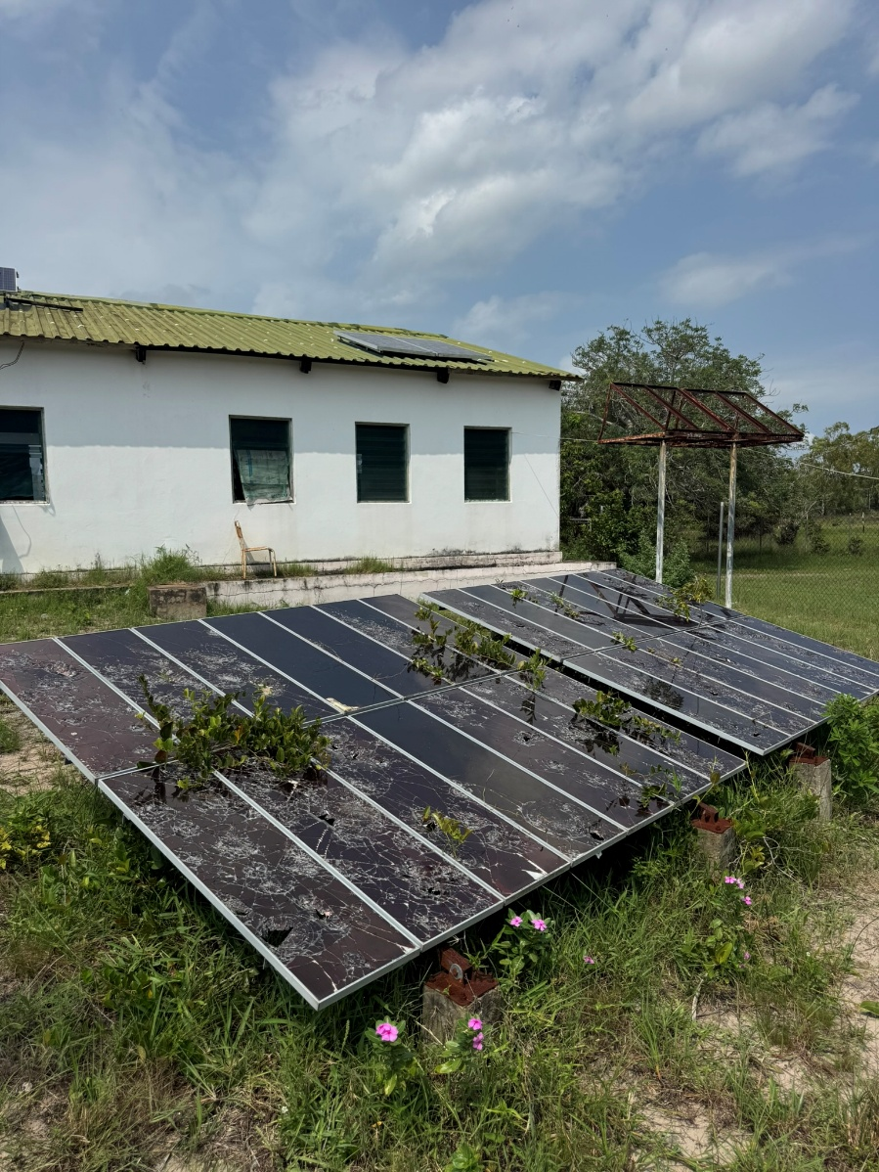
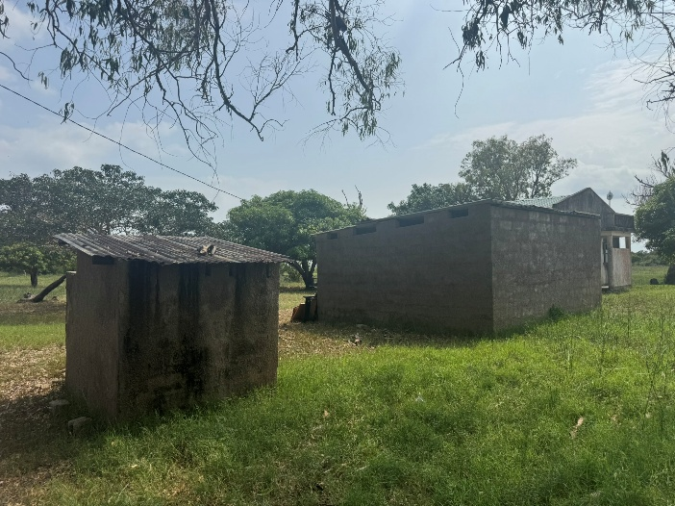
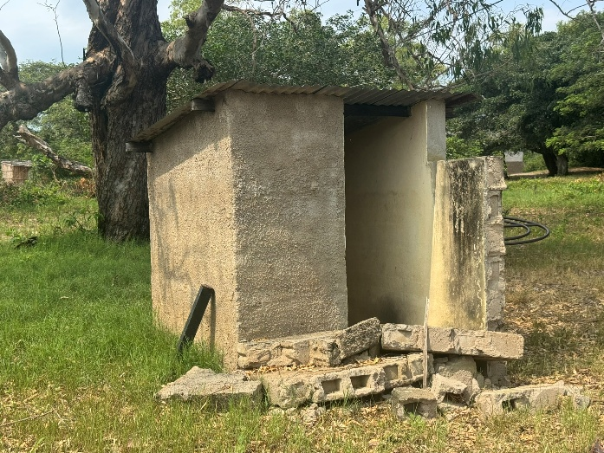
Picture: Solar System at Machubo HCF
Picture: Sanitary Block at Machubo Secondary School

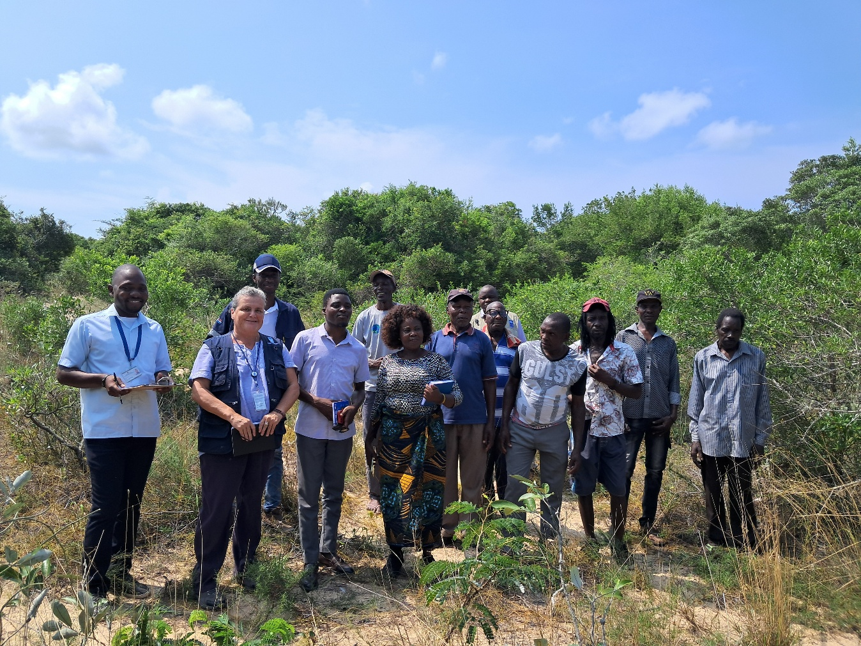
Picture: Representative of Machubo

